|  |
| --- |
| [Type the company name] |
| [Type the document title] |
| [Type the document subtitle] |

|  |
| --- |
| ztech  [Pick the date] |

TASK 1 : BURP SUITE –TASK

First I have open the kali linux then I open the burp suite .

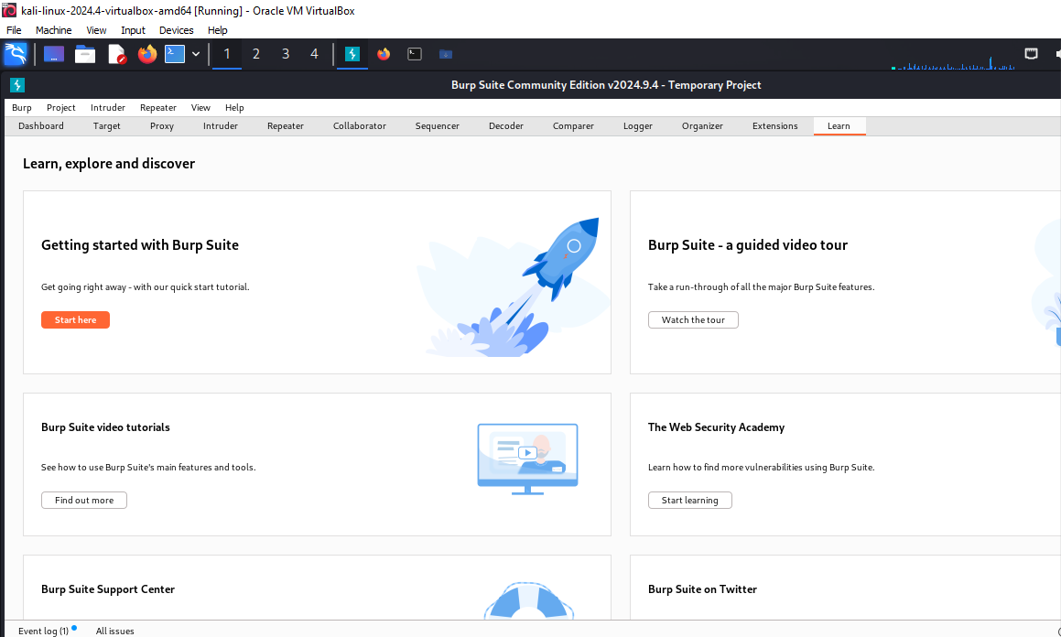

THEN I GO TO THE PROXY . I turn on the interceptor. Then I go to the browser.

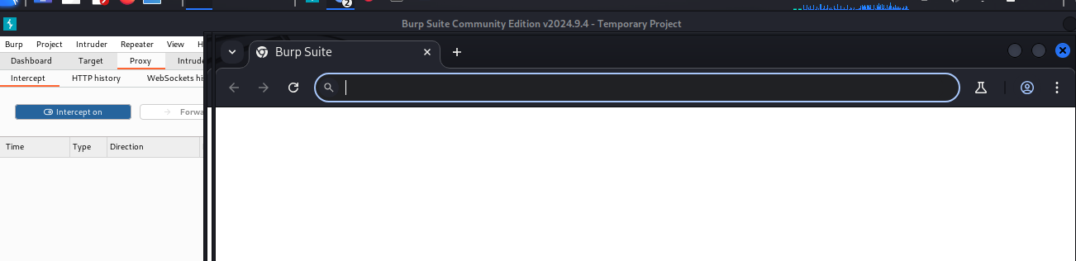

I searched about google.com

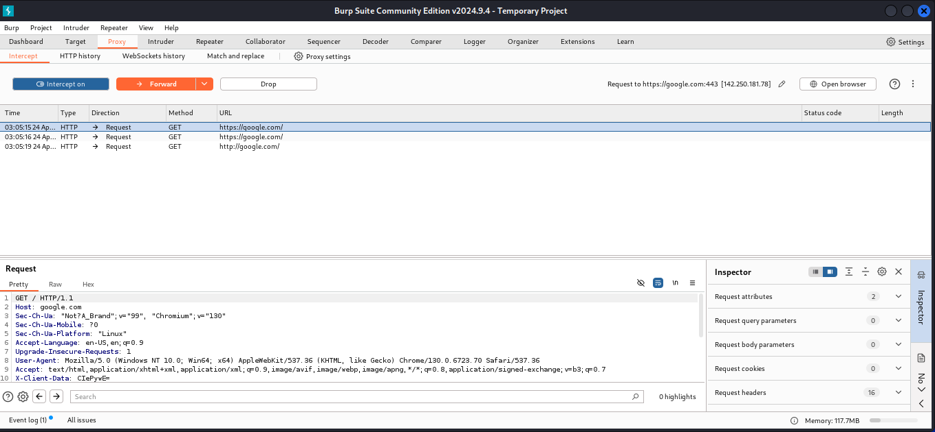

Here in the bottom I can see the interceptors.

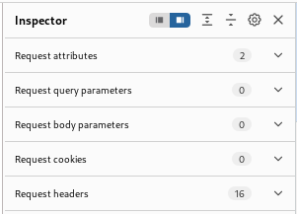

Task 2:

Go to the goggle :

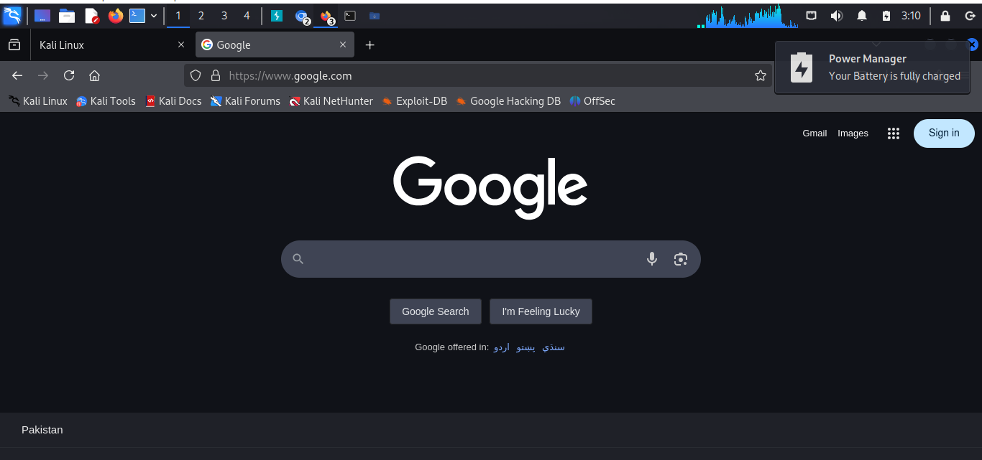

Task 3: then I go to the testfire.net app in google. And go to the sign in

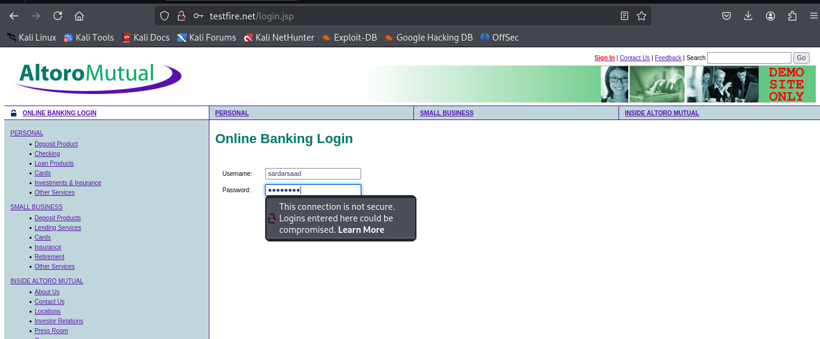

Task 4:

Go to intruder

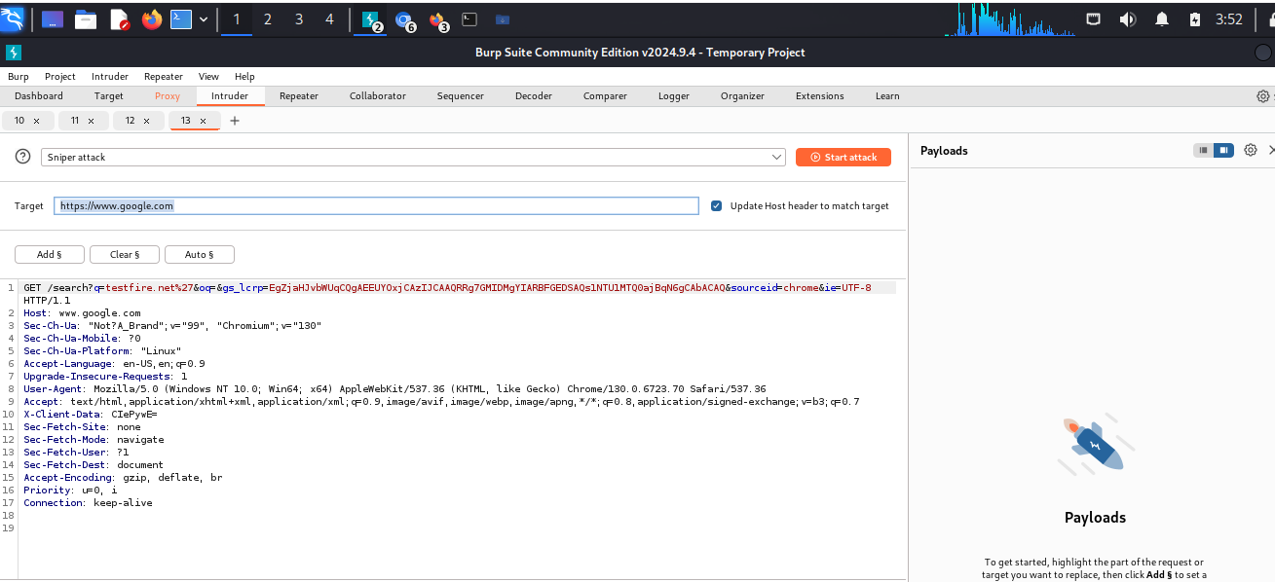

As I go to intruder but there no password and username is showed.

Now I resolve the error

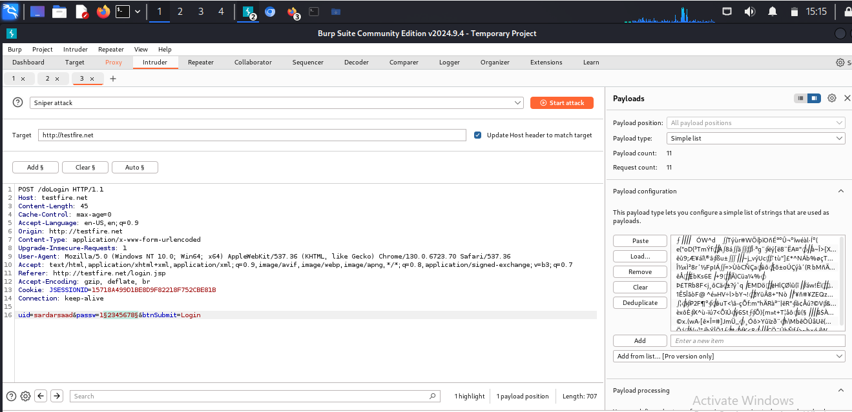

Then I choose password to do some change in it.

Steps:: Load>>user>>share>>wordelist>>rockyoufile

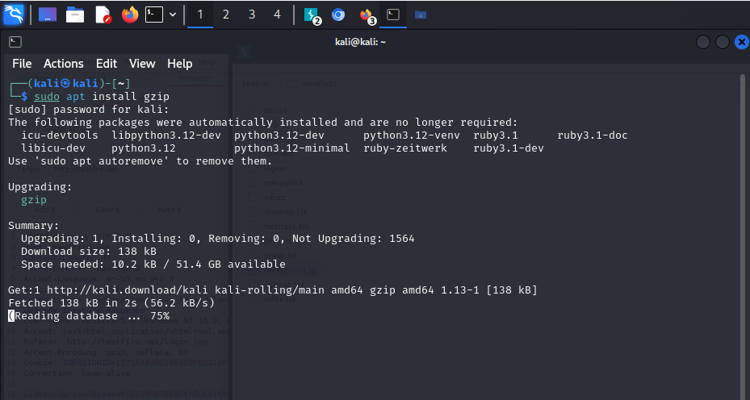

Then I unzipo the file by putting the command in the terminal.

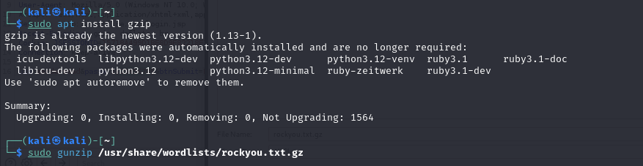



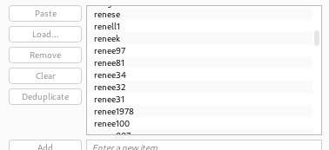

Then I start attack . but list is not shown ☹.

